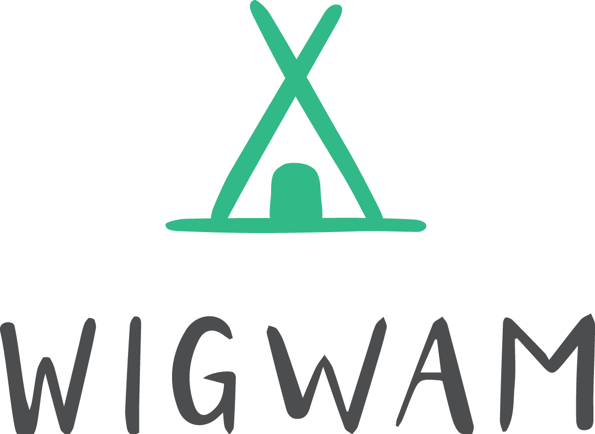
Wigwam Camp Registration Form
Please return to
Wigwamcamps@gmail.com
07748 882321

Child’s details
Child’s first name(s) |  |  |  |  |  | Surname
Date of birth
Family details
Name of parent(s)/carer(s) with whom the child lives:
Security password for persons collecting your child:
Contact details 1 (including emergency information/those authorised to collect your child):
Parent/carer full name
Daytime/work telephone |  |  |  |  |  |  | Mobile
Does this parent have parental responsibility for the child? Yes □ No □
Contact details 2 (including emergency information/those authorised to collect your child):
Parent/carer full name
Daytime/work telephone |  |  |  |  |  |  | Mobile
Does this parent have parental responsibility for the child? Yes □ No □
All policies and procedures referred to in this document are available for you to read on the following link https://wigwamforest.weebly.com/ts-and-cs-and-registration.html
Behaviour at Wigwam Camp
I confirm that I have read and agree to support Wigwam’s Promoting Positive Behaviour Policy including complying with my duties as a parent/guardian as outlined in the policy
Signed |  | Date

Forest School Permission
Wigwam operate Forest School and Bush Craft activities led by qualified Forest School and Bush Craft instructors. I understand that these activities and environments incorporate an element of risk, that may be above those encountered in normal everyday life. I am aware that Wigwam have policies and procedures in place for Forest School safety and that staff assess and manage risk, however I understand that risk cannot be eliminated from natural environments or Forest School and Bush Craft activities. I confirm that I give permission for my child to explore woodland environments in the knowledge that they may come into contact with animals, insects and members of the public and may engage in pond and river dipping, tool, fire and tree climbing activities
Signed |  | Date
Emergency Treatment
Emergency treatment declaration
In the event of an accident or emergency involving my child I give permission for the qualified first aider to administer first aid. I give permission for a qualified first aider to remove ticks in accordance with NHS advice regarding the risks of Lymes Disease. Additionally, I understand that Wigwam will contact the emergency services in the event of a medical emergency and every effort will be made to contact me, and in my absence the emergency contact provided in this form. I understand that if my child requires emergency treatment they will be taken to hospital in an ambulance and health care professionals will be responsible for any decisions on medical treatment in my absence, including the use of anesthetic and/or blood transfusions. I confirm that I have informed Wigwam of all medical conditions and treatments that my child requires and agree that I will notify Wigwam of any changes to this and I agree to the above procedures
Signed |  | Date
For inhalers/auto-injectors (e.g. Epipens)
I take full responsibility for providing Wigwam with the correct medication as prescribed for my child, I confirm that this is labeled for my child, is in date and that there is enough medication for the time period they are due to attend Wigwam. Additionally, I give permission for a named member of staff who has been appropriately trained to support the administration of the inhaler/Epipen.
Number of Epipen’s or Anapen’s or inhalers (supplied by me) to
Signed |  | Date

I understand that Wigwam cannot under any circumstance administer medication that has not been prescribed for my child, including but not limited to pain relief and anti-histamine and that Wigwam reserve the right to refuse admittance to children who are unwell or send them home if they become unwell at camp. I confirm that I have read and understand Wigwam’s risk assessment for Covid-19. I understand that Wigwam have created a risk assessment to reduce the risk of infection to children, staff and their families, however this risk cannot be eliminated and by choosing to send my child to a holiday provision I am increasing the risk of infection for my child and family and subsequently take all responsibility for this decision. I agree that I will send a child whom is deemed to be vulnerable or if there are vulnerable members of our household. I agree not bring my child to Wigwam if they, any members of our family, or any persons we have had contact with in the last two weeks display any symptoms of Covid 19. Including, but not limited to; a high temperature, a new and persistent cough, a sore throat, loss of sense of taste and/or smell. Additionally, I understand that if my child becomes unwell with covid 19 symptoms during the course of the session, they will be required to isolate from the group with a member of staff until I collect them. The remainder of the sessions will be cancelled and all children sent home to complete one week of isolation and two weeks for all other family members in accordance with government requirements.

Signed |  | Date
I agree to dress my child in accordance with Wigwam’s kit list available on the link provided above. I understand that Wigwam may refuse entry to children whom are not dressed appropriately for the weather conditions or activities and agree to take full responsibility for the application of sun protection
Signed |  | Date
About your child
Allergies and intolerances
Is your child known to have any allergies or food intolerances? If so, please specify:

Does your child have difficulty with any of the following:
Eating and drinking | Yes | □ | No | □
Walking, running, climbing | Yes | □ | No | □
Using the toilet | Yes | □ | No | □
Any other concerns:
Tetanus vaccination
Due to the risks involved in working in an outdoor environment I understand that Wigwam will not accept bookings for children who have not received their tetanus vaccination (The Tetanus vaccination forms part of the NHS Childhood Vaccination Programme). This is due to an increased risk of them contracting Tetanus from soil and outdoor equipment. I confirm that my child has received their tetanus vaccinations
Signed |  | Date
Photographs
For training, publicity and marketing purposes, Wigwam regularly take photographs and videos of the children during their play. Only cameras supplied by the setting are used for this purpose, photographs taken are used for display, marketing on leaflets, flyers, magazines and on the internet in accordance with Wigwam Forest School’s Privacy Policy and agreement under GDPR that has been sent to you.

I give permission for |  |  | (name of child) to have her/his photo taken, or to be
videoed, as per the above conditions.
Signed |  |  |  | Date
Terms and Conditions and Privacy our agreement
I confirm that I understand Wigwam’s Privacy Policy, Behavour Policy, Terms and Conditions of booking and Covid - 19 risk assessments are available to view on the following link https://wigwamforest.weebly.com/ts-and-cs-and-registration.html and understand that by signing this document I agree to Wigwam’s Privacy Policy and agree to abide by the Behaviour Policy, Covid-19 risk assessment and the terms and conditions as set out in Wigwam’s Terms and Conditions document
Signed |  |  | Date
Printed name

