Parent Letter
Summer 2018
Wigwam Forest School

Dear Parents

The sun is here and what fun we have had in it!

The Wigwammers have enjoyed many a stroll up to Chapel Common and were fortunate to chance upon one of the most beautiful bluebell forests we have ever encountered. The children took a moment to take in the view.
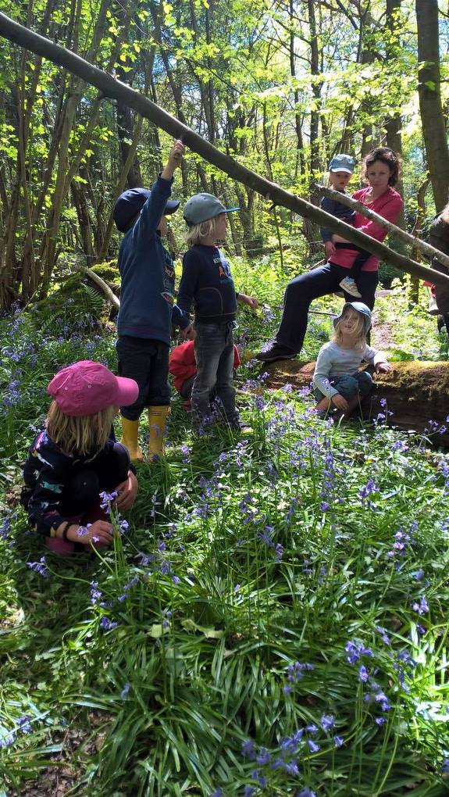

Later we painted still life pictures using watercolour, you may find a few on display in the classroom.

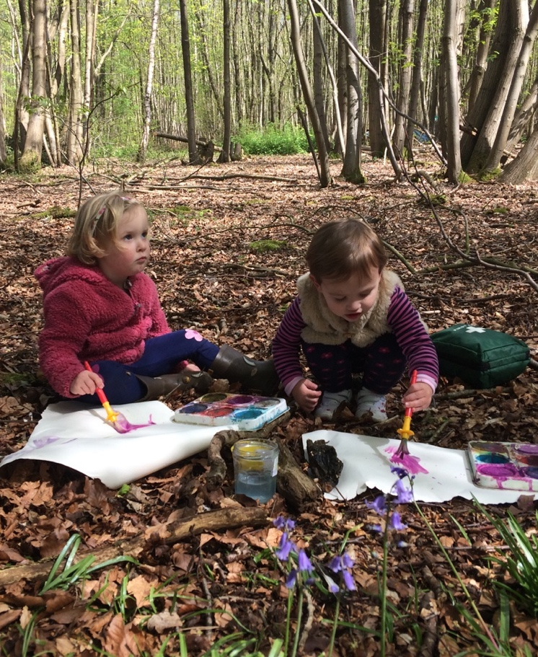

This term we have looked at the role of bees in pollination, visiting the local nursery to look more closely at plants in different stages of development. Here is a photo of rather popular plant, we hope we will have some of our own popping up at Wigwam soon!

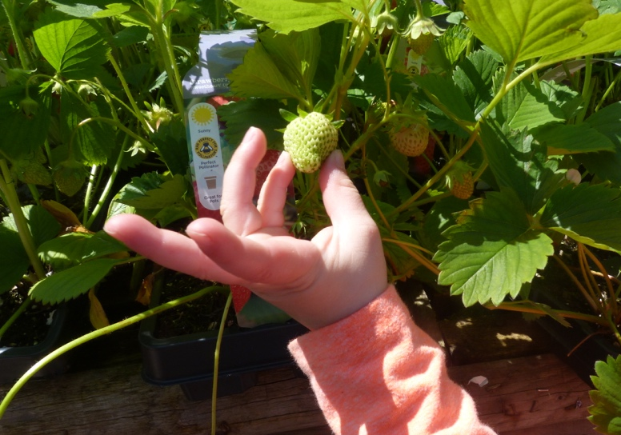

We continued with our exploration of the life cycle. We are happy to report that the class one’s tadpoles are growing by the day. It won’t be too much longer before they shed their tails and hop off, hopefully not in the classroom!

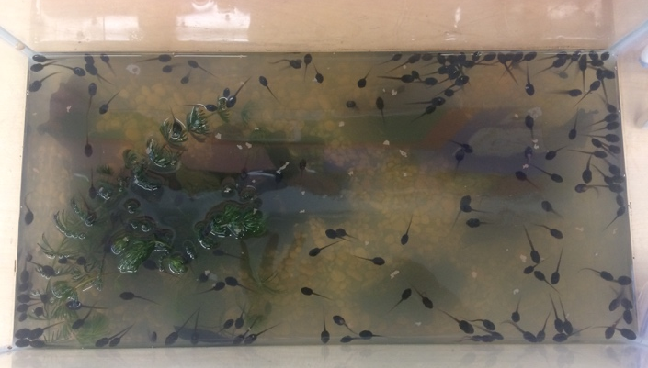

At the beginning of this week we visited Marden Farm, setting loose the ducks and hand feeding the lambs under the backdrop of the downs. The children were able to sit in a huge tractor and set off at speed in the back of a trailer.

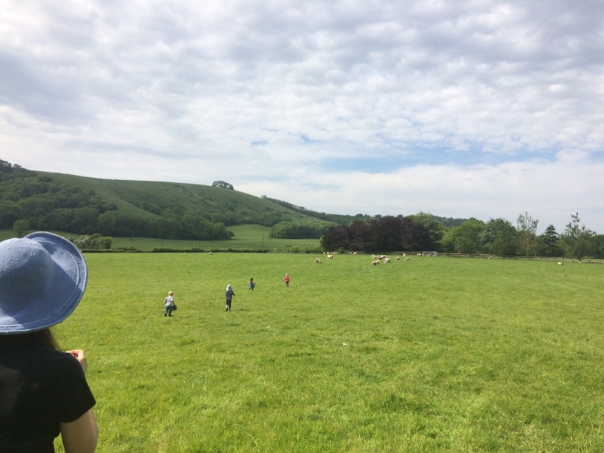
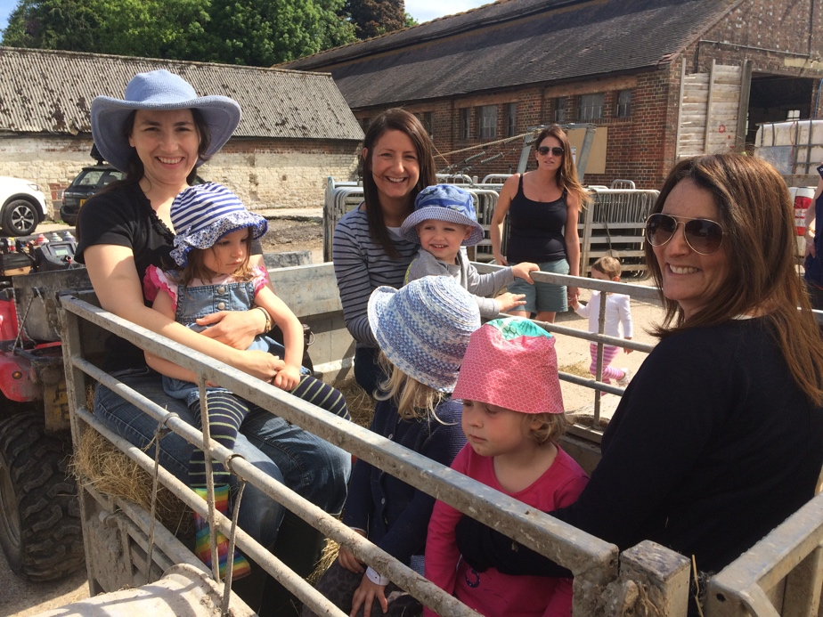

On return from our trip to Marden Farm we washed and brushed the wool we collected. After a couple of days it lost its pungent smell and we replaced it with turmeric… The children used a hot water and spice mixture to add yellow to our wool, later making their own felt for craft after half term.

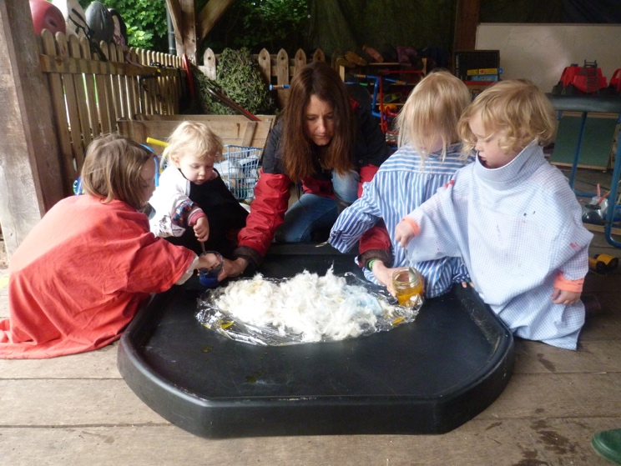

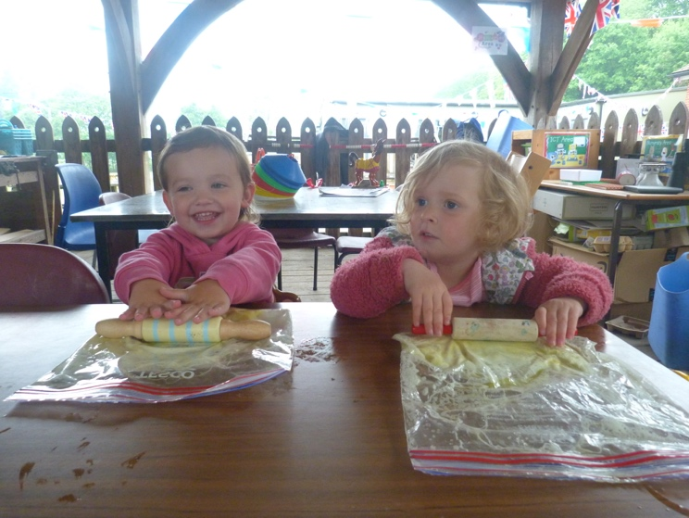

So here we are, another holiday, wishing you all a lovely break!

Very best wishes
Natalie and Frances

