Parent Letter
Summer 2018
Wigwam Forest School

Summer Term 1, the life cycle!
Wigwam Forest School
1 Marden Way, Petersfield, Hants
07950 887901

Dear Parents

What a wonderful start to our summer term, offering a warm welcome to our newest team member Gem Eagles. Gem is a qualified Early Years Teacher studying for her level 2 Practitioner Award in Forest Schooling, we are very excited to have Gem with us on Wednesdays! Our newest Wigwam members Sam, Tabitha, Johanna Adele have also settled in incredibly well over the past two weeks!

On our return from Easter break the children noticed some of the first signs of spring, investigating buds and new tree shoots in our woodland.

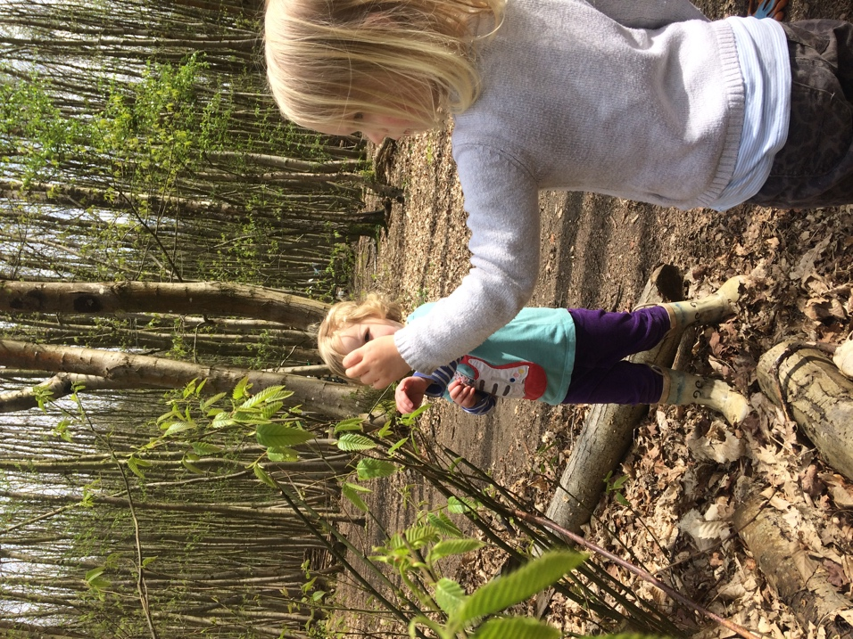
A belated but warm welcome to our new Wigwam members, it feels like they have been with us since the very beginning. We are so pleased to report that our new members have settled in beautifully.

Spring term began with goldilocks and the three bears and cooking porridge over our biomass stove. The children enjoyed writing invitations to their teddies and hosted a teddy bears picnic in the woods.

It wasn’t long before we experienced sub-zero temperatures recording a chilly -4 degrees Celsius on our thermometer. Naturally drawn to puddles the children noticed something was amiss and explored the

We found out some interesting facts about the ‘Common Spanish Slug’ quite literally invading our woodland. With green blood and a stinky slime, they mark their route home. The children especially liked testing their sticking power on a vertical surface and made some creative slug sculptures out of clay.

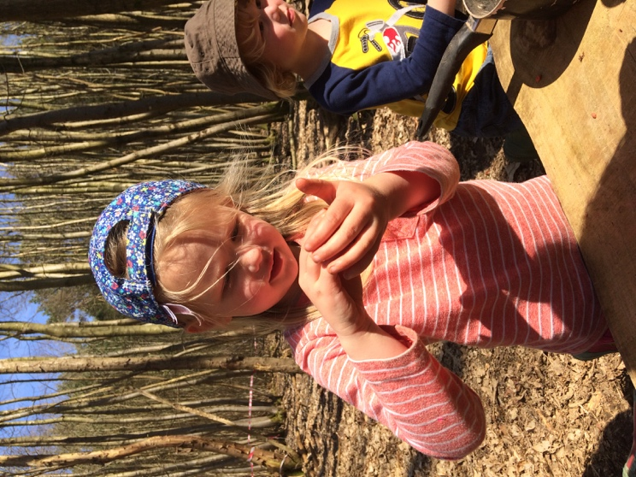

This week we extended our investigations of spring with a spot of pond dipping. We found many a creature nestled in the blue; damsel fly larvae, pond skaters, tadpoles and frogs. This naturally lead to discussions about the life cycle of a frog, with singing and games.

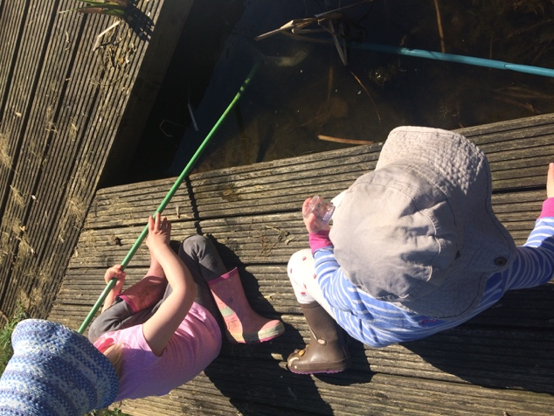

The year sixes have continued to visit us daily to read story’s to our Wigwammer’s and last week they also provided great entertainment in the woods through their invention of a giant and majestic seesaw, created using a tree they had felled and placed between two tree stumps, lots and fun and giggles ensued.

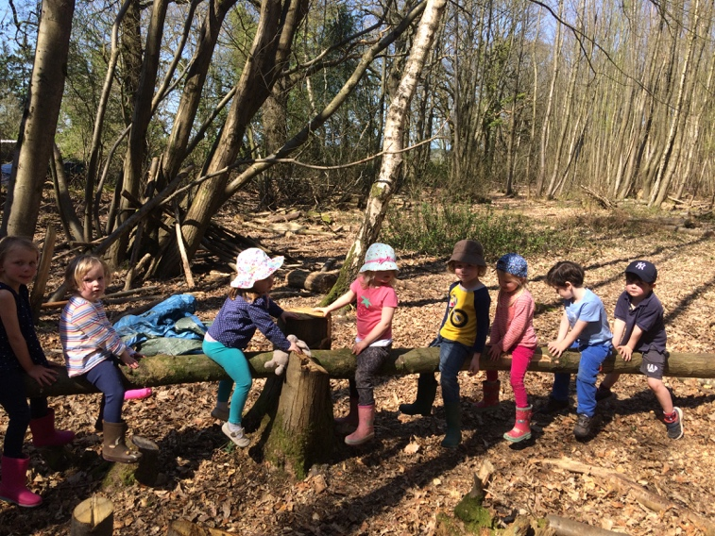

On Wednesday, we had to vacate our usual woodland plot for forestry works and decided to take a trip to Chapel Common. The children climbed the climbing tree and met Taffy the dapple grey horse. We covered approximately 2 miles of ground on foot and on our return to school the children still mustered the energy to run around the sports field, I imagine they slept well on Wednesday evening.

Finally, we are very excited to announce that Gillian Keegan, MP for Chichester, has requested to join us to find out a little more about what we do at our Forest and Montessori School. More details to follow…

Very best wishes
Natalie and Frances

